Shirt with cutouts on the shoulders
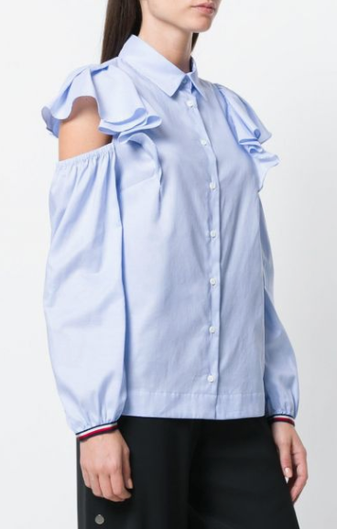
Details:
- Tommy Hilfiger off-the-shoulder blue cotton shirt with long sleeves, frilly sleeves and rushed design.
- 95%Rayon,5%Spandex, lightweight, soft and comfortable to wear.
- Cold shoulder tops with high low-cut design, easy to dress up and dress down.
- Casual relax fit style, deep v neckline, perfect short sleeve tunic tops for summer.
- This tee shirts is great with jeans, denim pants, high waist shorts, leggings, trousers.
- Perfect summer t shirts nice for beach, party, date, office, business, work, vacation, and special occasions.
- Note: Machine washable in gentle, recommend hand wash in cold water, line dry, do not blench, low iron if necessary.

$300

